Car Dealership Website Astra:

“Driving Dreams into Reality”

Ajith Ashok (AM.SC.U4CSE23204)

Arjun Rajesh (AM.SC.U4CSE23208)

Yadhu Vipin (AM.SC.U4CSE23270)

Velmura Rakshann (AM.SC.U4CSE23268)

GITHUB LINK: https://github.com/arjunr24-su/UID-project.git

# 1.Project Summary

## 1.1 Project Overview

This Car Buying Website is designed to provide a seamless and comprehensive platform for users to explore and purchase their desired car. The website will offer a wide range of car brands and models, allowing users to compare specifications and features easily. The platform will also include a customer care feature to address any queries and concerns promptly.

## 1.2 Project Scope

The Car Buying Website aims to simplify the car buying process by bringing together all relevant information in one place.

* Users can browse through various car brands and models, compare specifications, and make informed decisions.
* Users will also have the option to add multiple car options as a bookmark

The website will also support customer care to ensure a smooth and satisfying experience for all users.

# General Description

## Product Functions Overview

**Customer Features :**

**Brand and Model Comparison:** Users can compare specifications and features of different car brands and models to make informed decisions.

**Customer Care:** A dedicated customer care feature will address user queries and concerns promptly.

**Easy Navigation:** The website will be designed to make it easy for users to navigate through different car brands and models, reducing the need to visit individual car websites.

**Easy Payment:** Our platform will offer a seamless and secure payment process. Users can choose from a variety of payment options such as credit/debit cards, net banking, and EMI facilities. We ensure that all transactions are encrypted and your financial information is kept confidential. This feature aims to make the car buying process as smooth and hasslefree as possible.

## Team Member Feature Ownership

|  |  |
| --- | --- |
| Team member | Feature Ownership |
| Yadhu Vipin | Developed the homepage, about us page, login and signup pages. Also handled the Node.js and MongoDB backend for input. |
| Arjun Rajesh | Developed the chatbot using HTML, CSS, and JavaScript based on OpenAI's ChatGPT. Also created the car preference forms and the React welcome page. |
| Ajith Ashok | Developed the car brand websites, with a special focus on the BMW webpage. Also handled the PHP and MySQL backend for each page |
| Rakshann | Created the car gallery and the HTML files for each BMW model. |

**User Interface:**

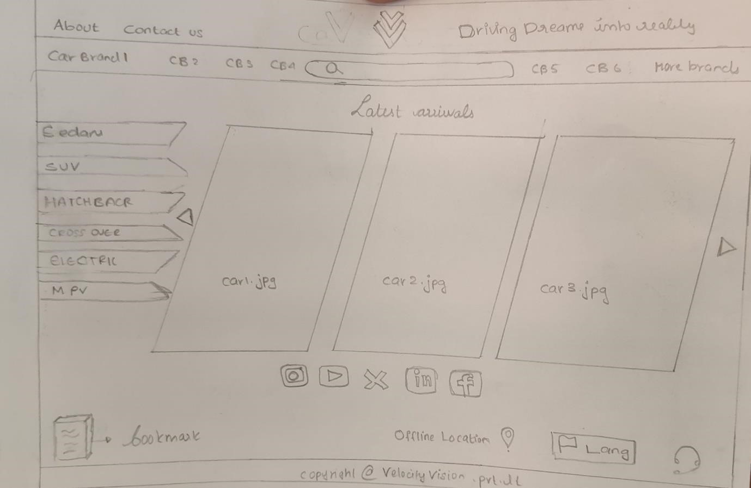

Rough idea